Summary – 21 Elements Meeting TAC 20
Thursday, December 5, 2013
San Carlos Public Library
610 Elm Street, San Carlos

Jurisdictions and Others in Attendance
Atherton, Belmont, Brisbane, Burlingame, Colma, Daly City, East Palo Alto, Foster City, Half Moon Bay, Hillsborough, Menlo Park, Portola Valley, Redwood City, San Bruno, San Carlos, San Mateo, San Mateo County, and South San Francisco.

Also in attendance were C/CAG, Community Legal Services of Palo Alto, CTP Planning, Habitat for Humanity, the Housing Leadership Council/HEART, LAFCo, Mercy Housing, MidPen Housing, the Office of Assemblyman Rich Gordon, and Peninsula Interfaith Action.

The meeting was facilitated by Joshua Abrams and Jeffery Baird of Baird + Driskell Community Planning.

Developer Panel
Mercy Housing , Tim Dunn
MidPen Housing Corporation, Nevada Merriman, Senior Project Manager
Habitat for Humanity, Deven Richardson, Director of Real Estate Development
Van Meter Williams Pollack, Rick Williams, Partner, Architect, Urban Designer
Bridge Housing, Brad Wiblin, Vice President

The panel addressed present and future concerns in housing development, such as community politics, the growing senior population, and the pressing need for more workforce housing. Key recommendations from the panel included:
- Conducting a program EIR to add certainty and speed to development approval
- Examining the density and FAR requirements. If they are out of balance, consider a variable density system where small units or senior units only count as a fraction of a unit (21 Elements will prepare a variable density fact sheet).
- Consolidate lot
- Consider increasing the density beyond 30 to allow better design.
- Reducing parking requirements, or creating separate parking requirements for affordable housing.
MidPen offered to meet with jurisdictions to discuss their available land inventory.

Website Update
A number of documents have been updated on the 21 Elements website, including housing needs analyses and parking standards summaries. There is now an easier way to access all of your data: under the Local Planning Efforts tab there is a pull-down menu that lists all jurisdictions, and leads to a page with jurisdiction specific documents. Jurisdictions are encouraged to ask 21 elements to customize this page to include meeting announcements or other information.

See end of document for screenshots from webpage.

Public Participation Plan
HCD has explained that participation in the 21 elements meetings might satisfy public participation requirements, but that ultimately local advocates will decide if these meetings are sufficient. Thus, jurisdictions are encouraged to hold their own public meetings; particularly the jurisdictions with the five largest RHNAs, where advocates are most likely to be focused. The webpage contains a list of stakeholders which jurisdictions are encouraged to notify about pending meetings.

21 Elements has facilitated an ongoing series with various local stakeholders including developers (this meeting), architects, and developmental disability advocates. The next meeting (Feb 6th) will feature housing advocates, and the following meeting (April 10th) will feature special needs representatives.

In addition to customizing the 21 elements website to publicize meetings, 21 elements can also create a newsletter upon request.

Housing Needs Tables and Reports
Housing Needs Tables have been updated and are available on the 21 Elements website.

Final drafts of the Housing Needs Reports will be available on the 21 Elements website by December 19, 2013. Jurisdictions will return edits and comments within 2-3 weeks (during the week of January 9, 2014).

Countywide Housing Trends
21 Elements distributed a Countywide Housing Trends report summarizing key trends in San Mateo as identified through research and during the TAC 18 meeting in June, 2013. The trends identified are: the growing senior population, Millennials, the lack of workforce housing, and growing racial diversity. Please review this report and provide feedback.

Nexus Study
Many jurisdictions are compensating for the uncertain legal status of inclusionary zoning by adding impact fees to market rate housing and commercial developments. Barbara Kautz, a lawyer, has advised 21 Elements that jurisdictions will need a nexus study to ensure the legality of their impact fees. Foster City and 21 Elements are collaborating to produce a nexus study that covers multiple jurisdictions in the county, representing a considerable financial saving for participating cities.

Foster City circulated an RFP, interviewed several economic consulting agencies, and decided on who was going to move forward with the project.

21 elements will prepare a memo explaining the significance of this study for various jurisdictions.

Apartment Association/Bay Area Council Request
The meeting participants agreed that 21 Elements should invite the Bay Area Council to a meeting to discuss the request in person. Participants agreed the request, as it stands right now, is too long and detailed, and that they should reduce it to a couple key points.

Guest Speaker: Hong Ly, Cornerstone Partnership
http://affordableownership.org/
The Cornerstone Partnership seeks to preserve affordability homeownership options and community stability through a variety of programs. They are currently compiling a document of best practice affordable homeownership standards, which will be released in February. Affordable housing practitioners are encouraged to contribute their expertise at StandardsRoom.AffordableOwnership.org.

Next Meetings
The next meetings will be on February 6th, 2014 and April 10th, 2014. Josh will be on paternity leave starting in early February.

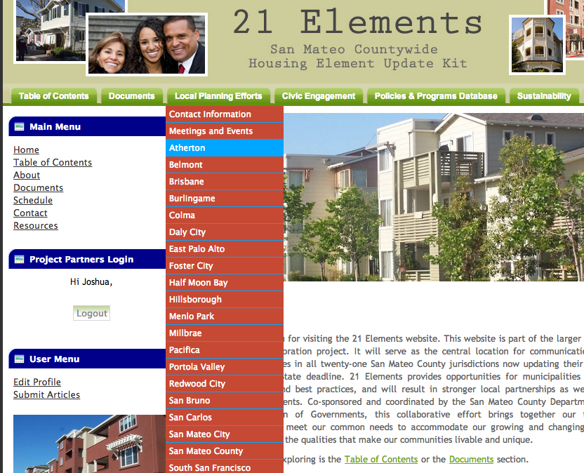
Figure 1- How to access your page and data
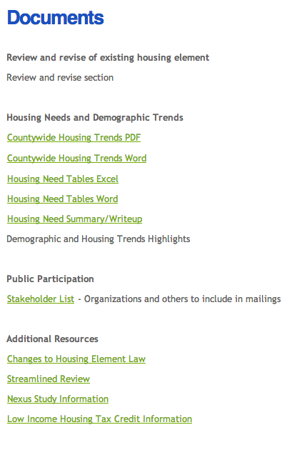
Figure 2- Default view for customizable page

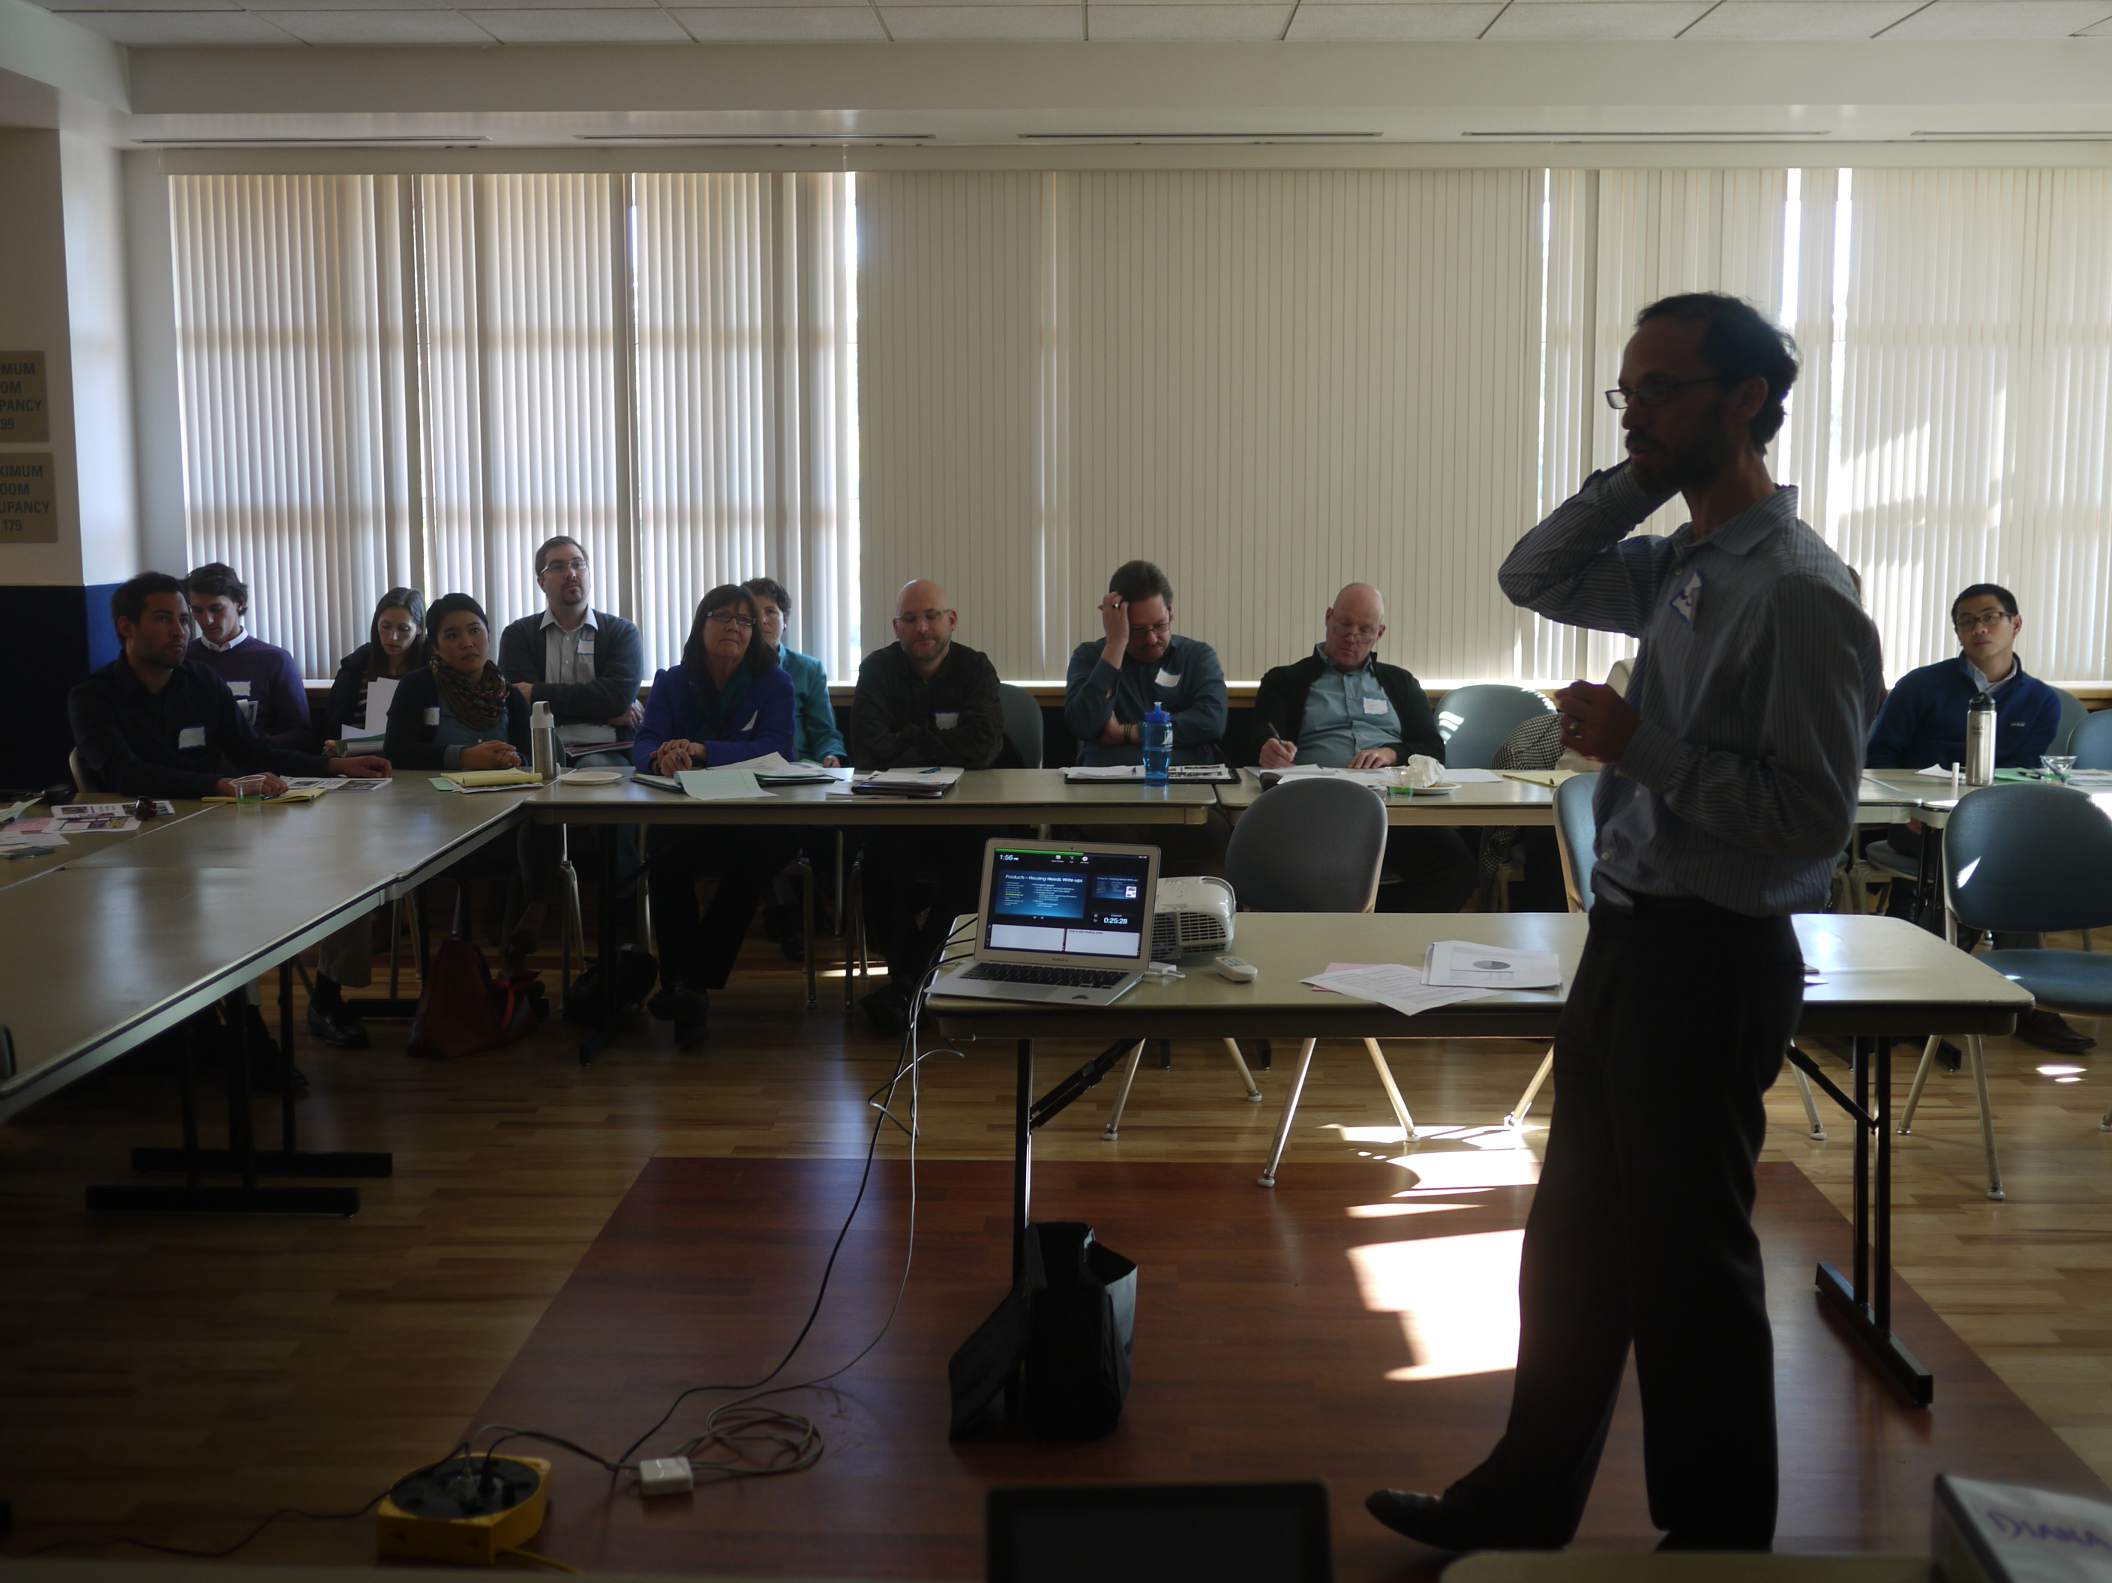
Figure 3- 21 Elements meeting

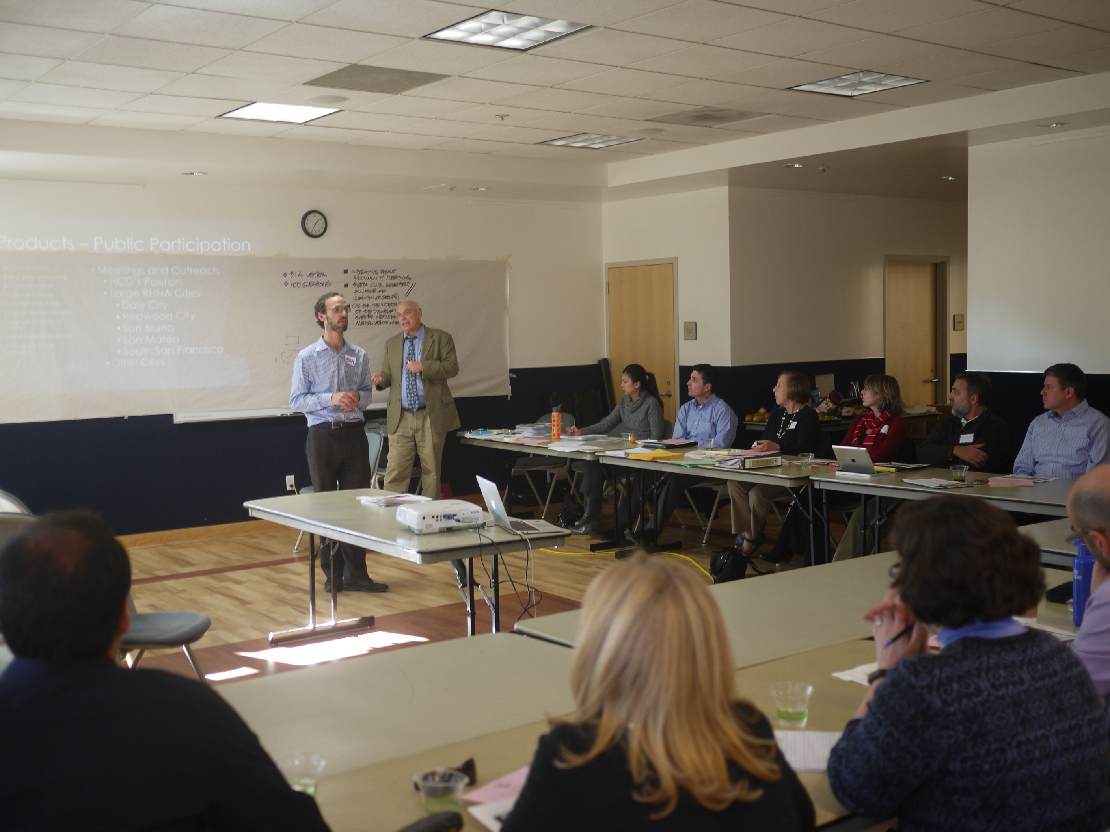
Figure 4- 21 Elements Meeting

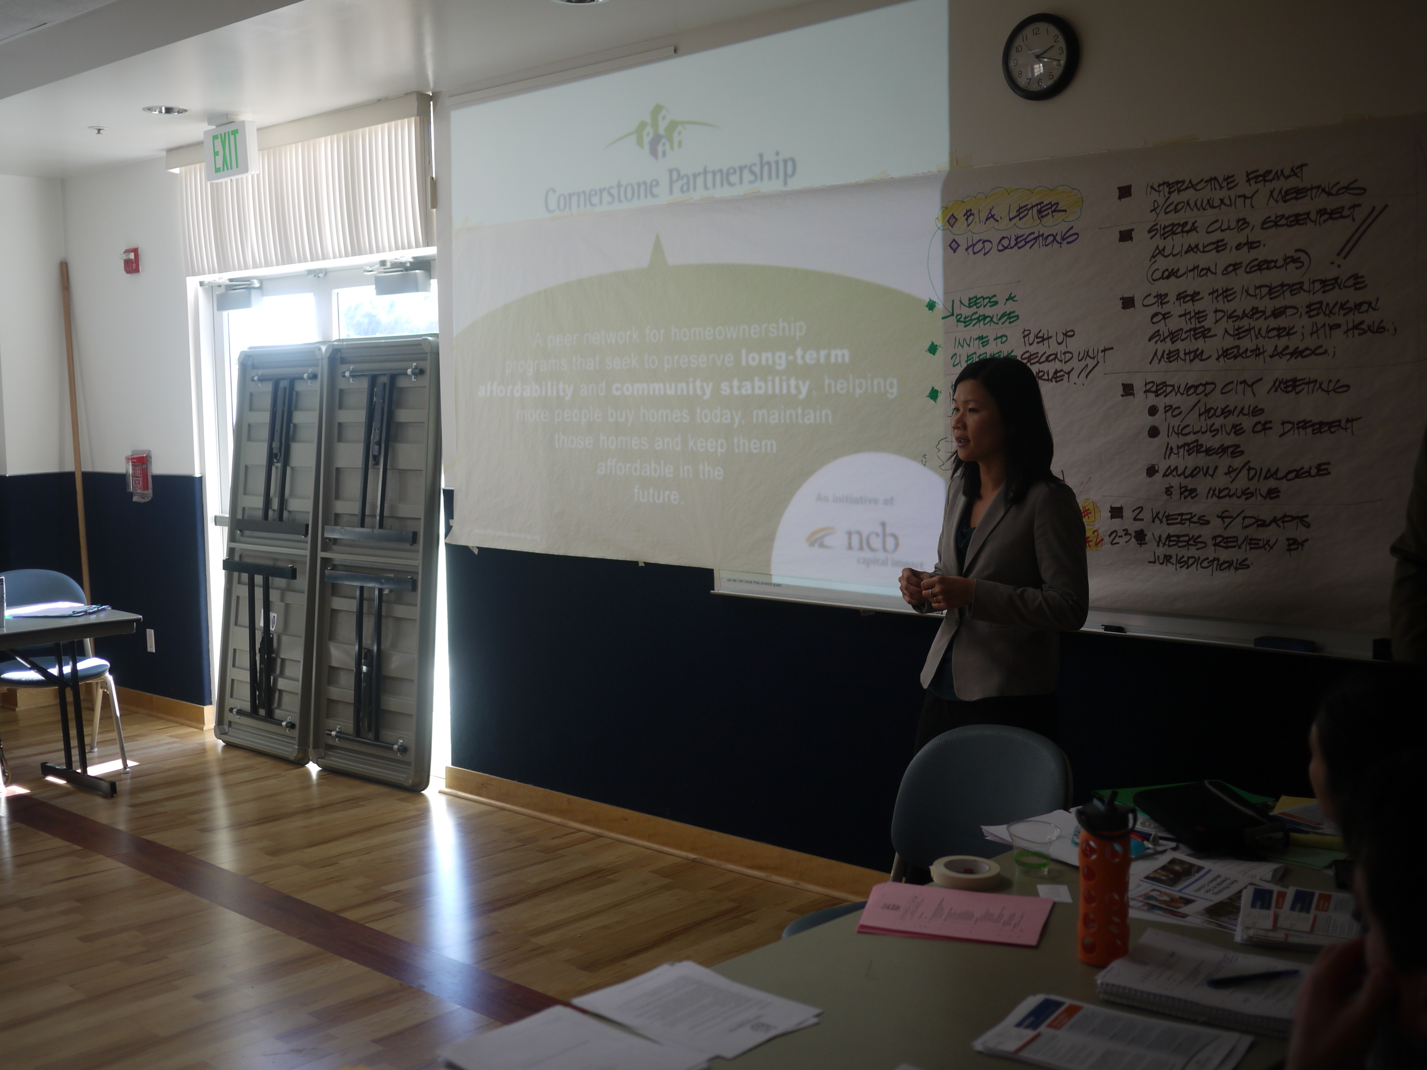
Figure 5- Hong Ly from Cornerstone Partnership addresses the 21 Elements meeting

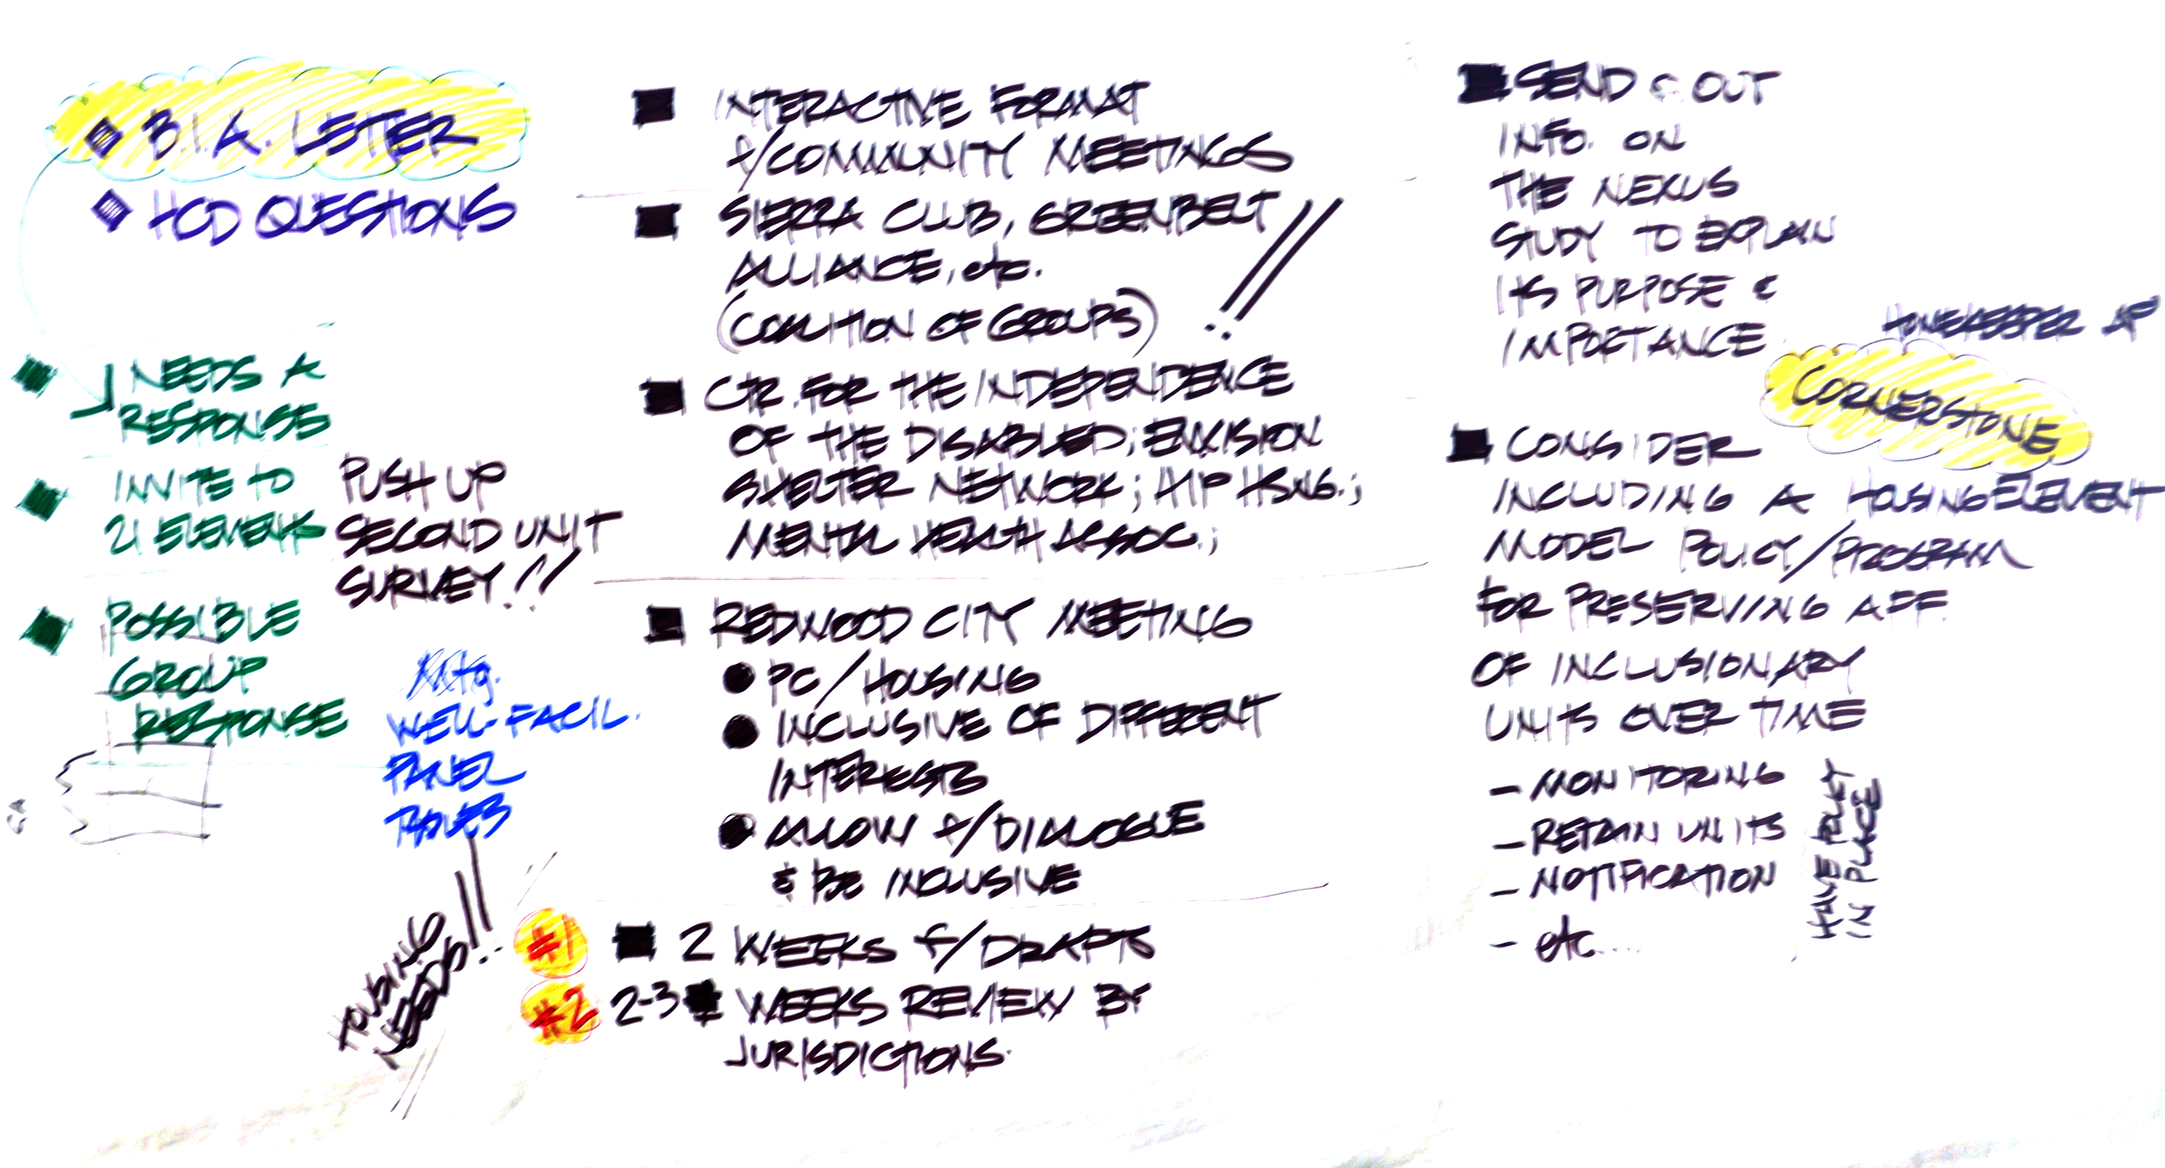
Figure 6- Notes from the 21 Elements Meeting

