Using HCD’s AFFH Data Viewer to view RCAAs
To view Racially Concentrated Areas of Affluence (RCAAs) in San Mateo County:
- Go to https://affh-data-resources-cahcd.hub.arcgis.com/
- Wait for it to load. Sometimes it takes a few minutes
- Click OK to start the program.
- Click on the red icon on the top right menu bar of the viewer. It looks like this (with no text).

- In the window that pops up, select the fourth option for RCAAs.
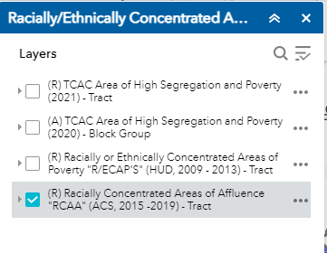

- Zoom in to your jurisdiction or region. RCAAs show up as a blue overlay.
Note: In HCD released this RCAA data in early July of 2022. We have discovered that these areas are different in some cases than those previously identified by ABAG. We recommend you examine the HCD maps and discuss where RCAAs are in your jurisdiction, and replace any ABAG data with HCD data. ABAG is working with HCD to update the HESS tool to be consistent with the AFFH data resources mapping tool.

