21 Elements – Getting Started
Site Strategies Analysis - Scenario Worksheets (Nov 16, 2020)

The purpose of this analysis is to test potential strategies for expanding your site inventory to meet projected needs (per RHNA 6), including analysis of how the market would likely respond to different changes in land use and development policy. It will not provide you with your final site inventory, but will help identify the most promising site strategies for you to pursue in your update process.

Each jurisdiction may submit data to run up to ten scenarios in total, divided into the following three categories: rezone scenarios, upzone scenarios, and additional scenarios (parking, inclusionary zoning and fees). You may of course choose to submit fewer, based on your circumstances and needs.

Three Rezone Scenarios
Strategies that Expand the Inventory of Sites Where Housing Is Allowed
Each jurisdiction may provide up to three sets of shape files and data tables to test three rezone strategies, introducing residential as a use in areas where it is not currently allowed.

Four Upzone Scenarios
Strategies that Allow More Housing on Sites Where Housing Is Already Allowed
Each jurisdiction may provide:
- Up to two sets of shape files and data tables to test upzoning strategies affecting existing residential zones as follows: increasing height, density, or other standards that allow for more of the currently allowed residential use; and
- Up to two sets of shape files and data tables to test upzoning strategies affecting existing residential zones as follows: changes in allowed residential use (e.g., going from single family zoning to duplex/triplex zoning; or from medium density to high density residential).

Three Additional Scenarios
Strategies that Promote Affordable Housing Outcomes
Each jurisdiction may provide shape files and data tables to test three strategies as follows:
- Changes to parking requirements
- Modified (or new) inclusionary zoning requirements
- Modified housing fees

Each jurisdiction will also provide or confirm the baseline (existing) zoning information (shapefile data and/or additional table of development standards) against which all of the above scenarios will be compared.

Scenario Development Worksheets

The following 10 narrative worksheets will help you and your team think through the details of each policy scenario you wish to model, along with the data that need to be provided. This information will help the analysis team have a good understanding of each scenario you plan to model.

For each scenario, you will need to consider (1) the development standards that will be applied (existing or new) and (2) where they will be applied (to existing zone districts, as mapped; or in selected areas). The following flow chart illustrates the sequence of questions and resulting data needs:

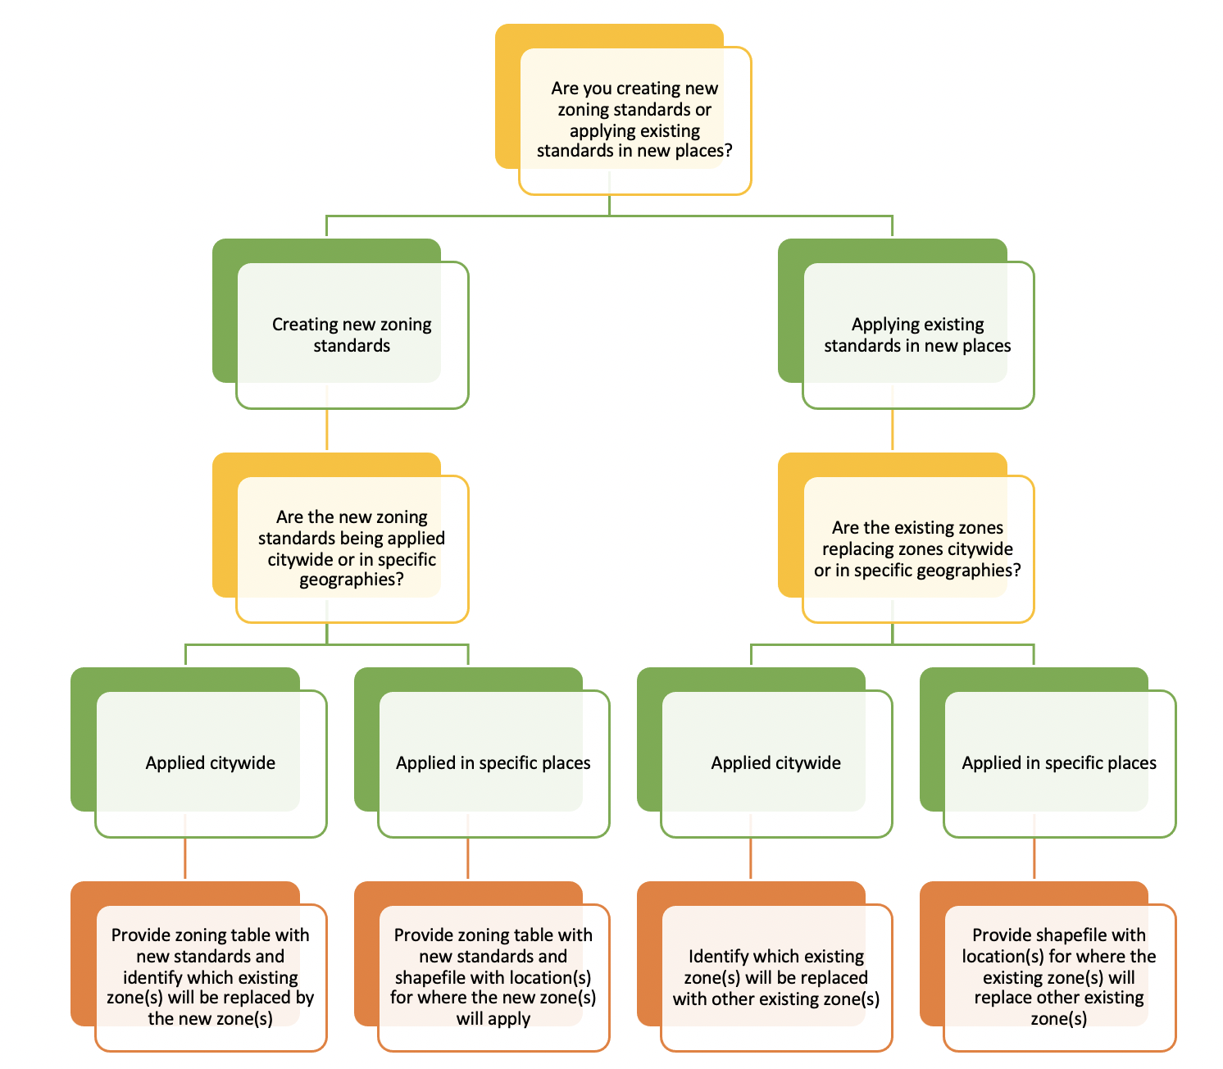

Rezone Scenario Worksheets #1 - 3: Instructions
Worksheets 1, 2 and 3 describe scenarios where you want to test how a change from non-residential to residential (or mixed use that includes residential) might perform in creating new housing units. For each worksheet:
- Provide a brief title for easy reference (e.g., Allow residential in Office Commercial zones).
- Provide a brief description of what you intend to test.
- Describe the areas that would be rezoned.
- Describe the standards that would be applied in the rezone areas.
Data and Process Questions to Consider | Examples
- Are you mapping (a) newly created zones or (b) existing zones?  - If you are creating new zones, you will need to add new rows to the zoning table with the name and values for all attributes of the new zone.  - If you are mapping existing zones, no changes to the zoning table are necessary. | Example 1a) create a new zone that allows residential, with new standards in the zoning table, and apply it to all existing commercial zones.  Example 1b) change all existing commercial zones into an existing mixed-use residential zone.
- Are you (a) swapping one zone for another zone (either new or existing) throughout the city or (b) in specific parts of the city, or (c) designating specific areas where specific zones will be applied?  - If you are swapping specific zones for other zones, you will need to provide a correspondence table with two columns: (1) current zone and (2) proposed zone designation. All parcels with the zone designated in the current zone column will be changed to the corresponding zone in the proposed zone column of the table.  - If you are swapping zones in specific areas, you will need to provide a correspondence table with current/proposed zones and a shape file that describes the limited areas where those changes will be applied.  - If you are designating areas where zones will be applied, you will need to provide a shapefile that identifies each parcel in your jurisdiction where the new zones should apply. | Example 2a) change R-2 zone to new R2B zone in all areas where R-2 exists.  Example 2b) replace an existing commercial zone with an existing mixed-use zone, but only within 1,000 feet of a transit stop.  Example 2c) rezone any location within a particular area to large-scale mixed-use residential.

Worksheet #1: Rezoning Scenario 1

Descriptive Title:

Brief Description of the Rezone Scenario

Standards That Would Change

Areas Where Rezone Would be Applied

Based on the specifications above, identify the data that will you need
- Will you need to provide a zoning table listing the specific attributes that are changing as part of creating a new zone for this scenario?
Yes No
- Will you need to provide a 1:1 correspondence table that describes the existing zone(s) and the zones (whether existing or new) that will replace it? Alternatively, will you be providing a new zoning layer that links the new standards to the defined geographies?
Yes No
- Will you need to provide shapefiles delineating the areas to be rezoned for this scenario?
Yes No

Worksheet #2: Rezoning Scenario 2

Descriptive Title:

Brief Description of the Rezone Scenario

Standards That Would Change

Areas Where Rezone Would be Applied

Based on the specifications above, identify the data that will you need
- Will you need to provide a zoning table listing the specific attributes that are changing as part of creating a new zone for this scenario?
Yes No
- Will you need to provide a 1:1 correspondence table that describes the existing zone(s) and the zones (whether existing or new) that will replace it? Alternatively, will you be providing a new zoning layer that links the new standards to the defined geographies?
Yes No
- Will you need to provide shapefiles delineating the areas to be rezoned for this scenario?
Yes No

Worksheet #3: Rezoning Scenario 3

Descriptive Title:

Brief Description of the Rezone Scenario

Standards That Would Change

Areas Where Rezone Would be Applied

Based on the specifications above, identify the data that will you need
- Will you need to provide a zoning table listing the specific attributes that are changing as part of creating a new zone for this scenario?
Yes No
- Will you need to provide a 1:1 correspondence table that describes the existing zone(s) and the zones (whether existing or new) that will replace it? Alternatively, will you be providing a new zoning layer that links the new standards to the defined geographies?
Yes No
- Will you need to provide shapefiles delineating the areas to be rezoned for this scenario?
Yes No

Upzone Scenario Worksheets #4 - 7: Instructions
Worksheets 4, 5, 6, and 7 describe scenarios where you want to test how changes to existing zones, either an increase in allowed intensity or changes in allowed uses, might perform in creating new housing units. Two scenarios can focus on changing standards such as height, FAR, units per acre, in one or more residential zone districts; and two can focus on shifting from lower density residential uses to higher density residential uses.
As in the Rezone scenarios, you will need to complete each worksheet with:
- Provide a brief title for easy reference (e.g., upzone single family to allow duplex/triplex).
- Provide a brief description of what you intend to test.
- Describe the areas that would be upzoned.
- Describe the standards that would be applied in the upzone areas.
Data and Process Questions to Consider | Examples
What zones will change? What attribute(s) of each zone will change? | Example 1) change R-2 zone to allow an additional 10 ft compared to today’s height limit.
Are you changing the parameters of a zone (a) citywide or (b) in specific locations?  - If you are changing the zone citywide, please state that.  - If you only want to change the zone in specific locations, you will need to provide a shapefile that identifies each parcel in your jurisdiction where the zone changes should apply. | Example 2a) change R-2 citywide to allow an additional 10 ft compared to today’s height limit.  Example 2b) change R-2 to allow an additional 10 ft of height in neighborhoods located east of 101.

Worksheet #4: Upzoning Scenario 1

Descriptive Title:

Brief Description of the Upzone Scenario

Standards That Would Change

Areas Where Upzone Would be Applied

Based on the specifications above, identify the data that will you need
For each upzone scenario, you will need to provide a table with the zones that are changing, including all of the new values for each attribute that will be modified.
[X ] Yes!
Will you need to provide shape files delineating the areas changing in this scenario?
Yes No

Worksheet #5: Upzoning Scenario 2

Descriptive Title:

Brief Description of the Upzone Scenario

Standards That Would Change

Areas Where Upzone Would be Applied

Based on the specifications above, identify the data that will you need
For each upzone scenario, you will need to provide a table with the zones that are changing, including all of the new values for each attribute that will be modified.
[X ] Yes!
Will you need to provide shape files delineating the areas changing in this scenario?
Yes No

Worksheet #6: Upzoning Scenario 3

Descriptive Title:

Brief Description of the Upzone Scenario

Standards That Would Change

Areas Where Upzone Would be Applied

Based on the specifications above, identify the data that will you need
For each upzone scenario, you will need to provide a table with the zones that are changing, including all of the new values for each attribute that will be modified.
[X ] Yes!
Will you need to provide shape files delineating the areas changing in this scenario?
Yes No

Worksheet #7: Upzoning Scenario 4

Descriptive Title:

Brief Description of the Upzone Scenario

Standards That Would Change

Areas Where Upzone Would be Applied

Based on the specifications above, identify the data that will you need
For each upzone scenario, you will need to provide a table with the zones that are changing, including all of the new values for each attribute that will be modified.
[X ] Yes!
Will you need to provide shape files delineating the areas changing in this scenario?
Yes No

Worksheet #8: Modified Parking Requirements

Descriptive Title:

Brief Description of Your Proposed Change in Parking Standards

Standards That Would Change

Areas Where the Changed Standards Would be Applied

Data and Process Questions to Consider | Examples
What aspects of your parking code will change? | Example 1) change requirement from 1.0 to 0.5 stalls per unit.
Are you changing the parking requirements (a) citywide or (b) in specific locations?  - If you are changing the policy citywide, please state that.  - If you only want to change the zone in specific locations, you will need to provide a shapefile that identifies each parcel where the changes should apply. | Example 2a) change parking req. s citywide from 1 to 0.5 stalls per unit.  Example 2b) change parking requirements from 1 to 0.5 stalls per unit on parcels within 1,000 feet of transit stations.
Based on your policy specification, identify the data that will you need
Provide your baseline and alternate parking tables. Include new values in the alternate table for those attributes that will be modified.
[X] Yes!
Will you need to provide shape files delineating the areas changing in this scenario?
Yes No
Worksheet #9: Modified Inclusionary Zoning Requirements

Descriptive Title:

Brief Description of Your Proposed Change in (or New) Inclusionary Requirements

The Inclusionary Requirements That Would Change

Areas Where the Changed Requirements Would be Applied

Data and Process Questions to Consider | Examples
What aspects of your inclusionary policy will change? If you do not have an inclusionary policy, what requirements will you test? | Example 1) increase low-income  req.s from 10% of units to 15%.
Are you changing the inclusionary zoning (a) everywhere the existing policies apply or (b) in specific locations?  - If you are changing the policy everywhere it applies, please state that.  - If you only want to change it in specific locations, you will need to provide a shapefile that identifies each parcel in your jurisdiction where the inclusionary zoning requirements / changes should apply. | Example 2a) change or introduce inclusionary zoning requirements everywhere so that 20% of units must be set aside at 80% of MFI.  Example 2b) change requirements only for developments within ½ mile of major arterials so that 20% of units are set aside at 80% of MFI.
Based on your policy specification, identify the data that will you need
Provide a baseline and alternate IZ policy table. Include new values in the alternate IZ table for those attributes that will be modified.
[X] Yes!
Will you need to provide shape files delineating the areas changing in this scenario?
Yes No
Worksheet #10: Modified Housing Fees

Descriptive Title:

Brief Description of Your Proposed Change in Fees

Details on the Fees that Would Change

Areas Where the Changed Fees Would be Applied

Data and Process Questions to Consider | Examples
Are you changing the housing fees (a) citywide or (b) in specific locations?  - If you are changing the fees citywide, please state that.  - If you only want to change the fees in specific locations, you will need to provide a shapefile that identifies each parcel in your jurisdiction where the fee changes should apply. | Example 1a) reduce housing fees $10,000 per unit.  Example 1b) reduce housing fees $10,000 per unit in developments within ½ mile of major arterials.
Based on your policy specification, identify the data that will you need
Provide a description of the fee reduction changes, including an estimated dollar value per unit.
[X] Yes!
Will you need to provide shape files delineating the areas changing in this scenario?
Yes No

