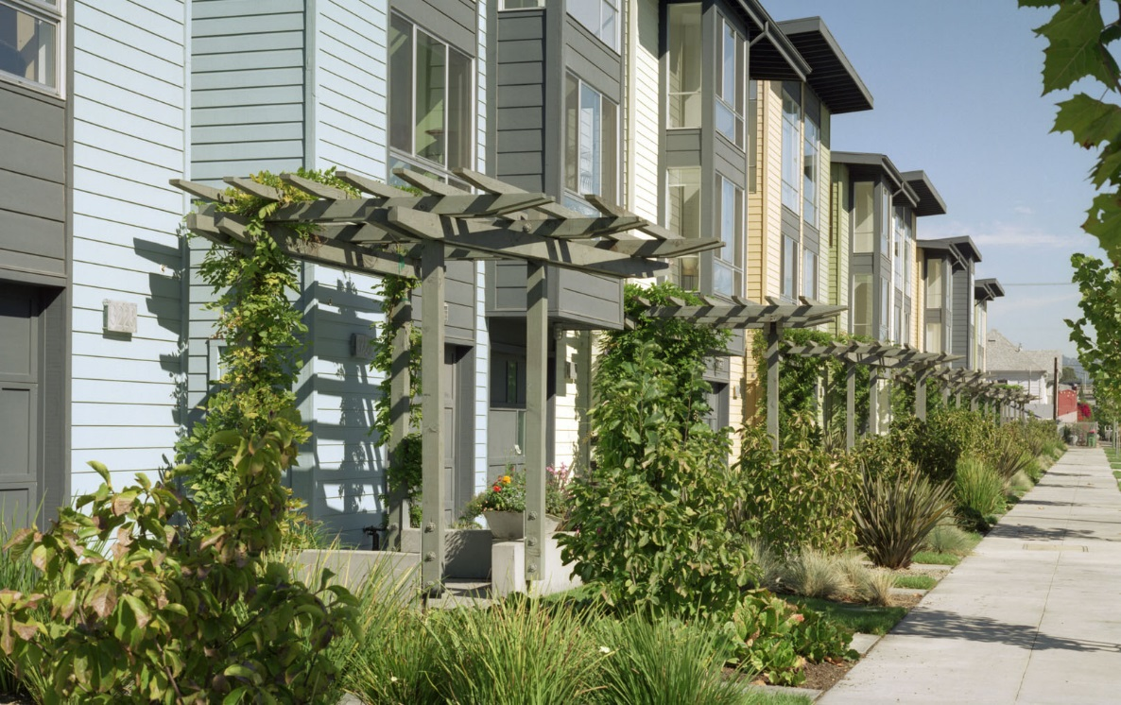

**Key Housing Trends in San Mateo County**

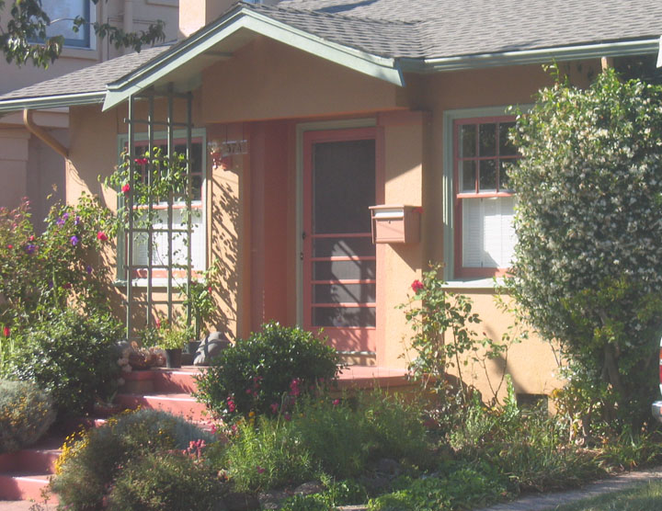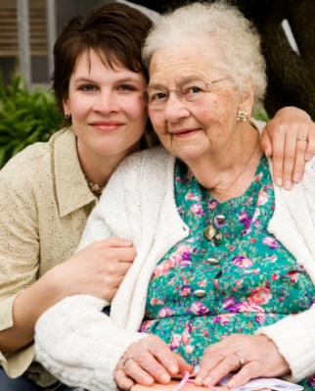

**A report by 21 Elements**

**2014**

**Key Findings**

|  |
| --- |
| 1. The **Millennial Generation**’s preferences will increasingly define the housing market in the coming decade. |
| 1. As baby boomers age there will be a ***Silver Tsunami***. Ensuring safe, desirable options for aging seniors will require advance planning. |
| 1. San Mateo County has a **Severe Workforce Housing Shortage** caused by years of rapid economic growth and slow housing growth. This trend is made worse by the increasing number of lower-income jobs. 2. San Mateo County, like California as a whole, has an **Increasingly Diverse Population** and the housing stock will need to meet the needs of these residents. |
|  |

Page 8

Page 6

Page 2

Page 4

The Millennial generation is a growing force in the housing and job market and their preferences will shape our communities in the future. Millennials have consistently expressed a preference for dense, mixed-use, walk-able and bike-able communities, according to studies by the Urban Land Institute and others. They want to live close to work, schools for their children, and public transportation. These amenities, in addition to safety and schools, are the top priorities for the Millennial generation.

**138,000**

Young adults in San Mateo County in 2015.

**158,000**

Young adults in San Mateo County in 2035.

**14%**

Increase in the young adult population from 2015-2035. In contrast, the population of those aged 35-59 will decrease. ABAG).

The Millennial Generation refers to individuals between the ages of 20 and 34 years old.

**Key Finding 1: Millennial Generation**

**The Millennial (ages 20-34) generation’s preferences will increasingly define the housing market in the coming decade.**





Due to this generation’s age and the recent recession, Millennials have been less likely to live on their own or own a home, but this is now changing (Harvard). As the economy improves, there will likely be a pent-up demand for housing among Millennials. Many studies have shown that Millennials rent apartments and buy homes at a rate less than previous generations. Instead, Millennials have moved in with their parents or choose to live with roommates. Many have speculated that Millennials may be a “generation of renters,” as there is less stigma to renting for this generation (Washington Post). However, trends are complex and approximately 69 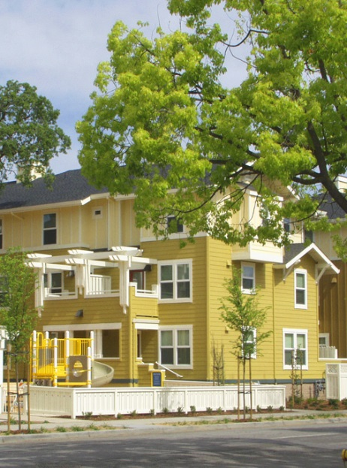percent of Millennials expect their next move to be to a house they own (ULI).

**Policy Options to Consider**

* **Build complete communities,** walkable and close to transit.
* **Provide diversity in housing** for a variety of income-levels and family-sizes. Many Millennials delay marriage and are looking for one bedroom or even micro apartments.
* **Support first time home buyers.** Millennials will need support as they purchase their first home. Ensure that there are adequate first-time homebuyer education programs.

Millennials are also value-conscious. They have less money than their older counterparts, in part because they have not had time to build up savings. They also must contend with higher rates of debt and a slow job market.

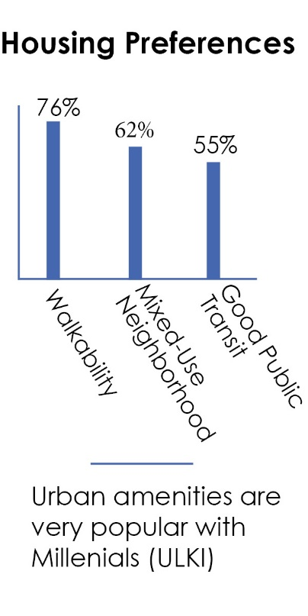

Urban amenities are very popular with Millennials (ULI)

The number of seniors in San Mateo County will increase dramatically over the next decade and a half, as the large baby boomer generation ages. The vast majority of seniors want to “age in place,” or remain in their current home or in their community as long as possible (AARP).

**Key Finding:** **Silver Tsunami**

**As baby boomers age, there will be a “silver tsunami.” Ensuring safe, desirable options for aging seniors will require advance planning.**



San Mateo County has the highest cost of living in California for seniors who both rent and own, according to a study by UCLA (DoH).

Seniors have special housing needs as a result of limited income and mobility issues that should be explicitly addressed. Almost 20 percent of seniors live below the poverty line after adjusting for housing costs (Stanford). Many seniors live on fixed incomes, which limits their housing options and also puts them at risk of being displaced.

**76%**

**2005 - 91,000 2025 - 160,000**

**Senior Popuation Change**

By 2030, one quarter of San Mateo County residents will be over 65 (Stanford)

4



Seniors who rent are at particularly high risk for being displaced by increasing rents. Seniors in San Mateo County typically see their income reduce by half as they age from their 50s to their 80s (Claritas). Furthermore, seniors who own are often *house rich* but *income poor*.

Assuming national trends hold and 90 percent of seniors plan to stay in their home, a large number, more than ten thousand San Mateo County seniors, will be looking to move in the coming years (AARP). Many seniors prefer to trade down to a smaller home with less upkeep. Safety is also a significant concern for seniors, as are universal design features (like level entry).

**Policy Options to Consider**

* **Assist seniors as they age in place** by providing key services, such as home modification assistance programs (low interest loans, construction management, etc.).
* **Support home sharing programs.** Home sharing, helping people with extra space find vetted roommates, is often the most cost effective way to help seniors stay in their homes. HIP Housing is a local nonprofit that facilitates home sharing.
* **Consider requiring universal design features** in new construction. Universal design calls for features, such as level-entry showers, which let everyone use a home, regardless of their physical ability.
* **Promote second units** (e.g. converted garages). Younger families will often use the space for an aging parent and seniors will often rent out the second unit (or the main home) for extra income.
* **Provide a diverse mix of housing options**, including affordable homes, small homes (for single person households), homes near transit, age restricted housing and other options.
* **Consider developing a senior housing plan**, bringing together various stakeholders to look at the issue in a comprehensive way.

Many seniors do not enjoy driving, and so walkability and the availability of nearby public transit are very important. Having a grocery store within a half mile of their home was the most important feature in a recent AARP survey.

Renters

Owners without mortgage

Owners with Mortgage

**Many seniors are house rich, but cash poor**

Percent of seniors who are economically insecure

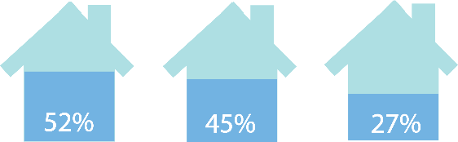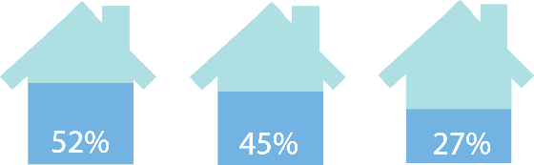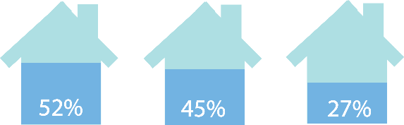

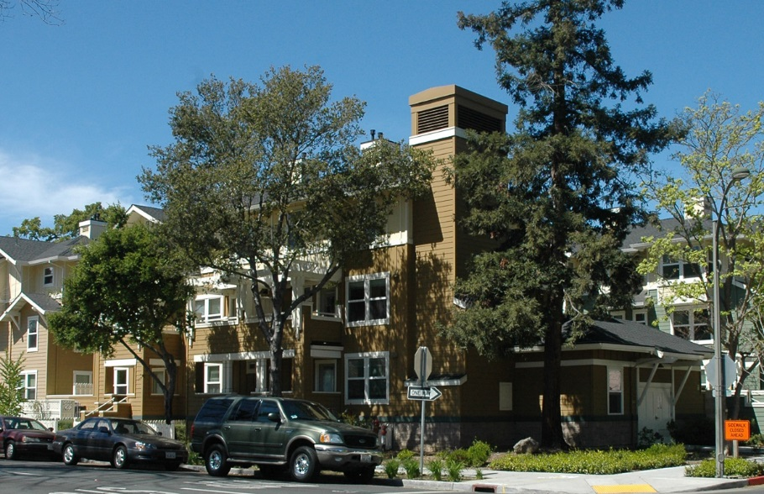For many years, job growth has been faster than housing production. This has caused a shortage in workforce housing. Job growth in San Mateo County has been picking up steadily since the recession, and is anticipated to be strong through the coming years. However, many of the new jobs created will be for lower-income workers.

**Key Finding 3: Severe Workforce Housing Shortage**

**San Mateo County has a severe workforce housing shortage caused by years of rapid economic growth and slow housing growth. This trend is made worse by the increasing number of lower-income jobs.**



By 2025 the housing supply will only meet one third to one half the demand for housing

According to the Association of Bay Area Governments, job growth is anticipated to average 1.7 percent annually in San Mateo County from 2010-2020, an increase of 5,800 jobs annually. In contrast, the number of new homes grew only four percent from 2000-2010 (U.S. Census). Much of San Mateo County’s job growth over the past decade has been in the lower-income sectors (Keyser Marston). Although San Mateo County’s well-paying high-tech jobs draw attention, 40 percent of the new jobs in the county will be low income.

6

**40%**

Of new jobs in the county will pay low income wages.

While San Mateo County has a steadily climbing median income among residents, it also has a growing income disparity between its higher-income residents and lower-income workers who live outside the county.

As Silicon Valley creates new jobs, the demand for housing also increases. Silicon Valley already has a serious mismatch of jobs to housing, with three times as many jobs as housing units. According to the Department of Housing, by 2025 the housing supply will only meet 1/3- 1/2 of the demand for housing.

This growing housing shortage is particularly a problem for lower-income families and individuals who currently cannot find affordable housing in San Mateo County. Projections show that this will develop into a deficit of 21,000 units by 2025 (DoH).

In the coming decade, only 15 percent of San Mateo’s new low-income workers will be able to live in the county (DoH). The effects of this are very real. Commute times are increasing, leading to more climate change gases being released. Also, longtime residents and children who   
grew up in San Mateo County are not able to live here.

**7-15%**

Yearly increase in rents in San Mateo County in recent years (DoH).

**22%**

Increase in home values (Sep 2012-Sep 2013, Zillow).

**Policy Options to Consider**

* **Adopt policies that ensure there is enough workforce housing,** such as inclusionary zoning, affordable housing impact fees or an affordable housing overlay zone.
* **Ensure there is adequate land zoned for residential development**, in particular near transit.
* **Encourage large employers to provide housing for their employees.** A number of schools and colleges, as well as companies like Facebook, have expressed interest in this.
* **Partner with nonprofit developers.**
* **Ensure the development process is predictable and efficient** while protecting the needs of the community. Form based code in Redwood City has been very successful at this.

According to the 2010 U.S. Census data, San Mateo County is a majority-minority county: that is, no one racial group makes up over 50 percent of the population. The two racial groups growing the most rapidly in San Mateo County are Asians and Latinos. According to the U.S. Census, the increase in the Asian population is largely due to recent immigration. Immigrant families are more likely to live in multi-family housing in denser neighborhoods (Pitkin and Myers). They are also more likely to live in intergenerational housing. In addition, recent immigrants are more likely to be linguistically isolated, which could create problems for the provision of services. The Hispanic population in San Mateo County is mostly growing due to “natural increases,” i.e., births are exceeding deaths. According to demographic data, Hispanic families often have more children than families of other races, partially because the Hispanic population is younger.

San Mateo County is currently *majority minority* and will become more diverse in the future.

**Key Finding 4:** **Increasingly Diverse Population**

**San Mateo County, like the state of California as a whole, has an increasingly diverse population and the housing stock will need to meet the needs of these residents.**



Both Asian and Hispanic families are more likely to live in multi-generational housing, though this trend diminishes as people have been in the United States for a longer period of time (e.g. second and third generation immigrants) (Pitkin and Myers 2008).

8

**Policy Options to Consider**

* **Ensure housing options for extended families.** Large apartments and second units are two options.
* **Provide information in multiple languages.**
* **Address housing discrimination.** Cities can clearly publicize rules about housing discrimination and work with Project Sentinel for complaints.

**Sources:**

**Millennial Generation:**

Association of Bay Area Governments. Projections 2009.

Harvard Joint Center for Housing Studies. “The State of the Nation’s Housing 2013.” 26 June 2013. Web.

Urban Land Institute. “Americans’ Views on their Communities, Housing, and Transportation.” March 2013. Web.

Washington Post. “New apartment buildings are geared for Millennials.” La France, Adrienne. April 17, 2014.

**Silver Tsunami**

AARP, 2011 telephone survey of 2260 adults. Summary titled *2011 Boomers Report*. Released July 2012.

Claritas, Senior Life Report 2012 for San Mateo County.

Department of Housing, *Building for the Boom*. 2009.

Stanford Center on Poverty and Inequality, A Portrait of Poverty within California Counties and Demographic Groups, 2013.

**Severe Workforce Housing Shortage**

Association of Bay Area Governments. Projections 2009.

Department of Housing, Annual Rent Survey, 2013

Department of Housing, *San Mateo County Housing Needs Study*. 2006.

Keyser Marston Associates, Inc. *Jobs Housing Nexus Study*. Mountain View, Ca. 2012.

**Increasingly Diverse Population**

Pitkin, John and Dowell Myers. *U.S. Housing Trends: Generational Change and the Outlook to 2050.* 2008.

San Mateo County Health System Study. *Healthy San Mateo 2010.* San Mateo, Ca.