PUBLIC HEARING NOTICE
CITY OF DALY CITY
PLANNING COMMISSION

DATE: Tuesday, May 5, 2020 TIME: 7:00 P.M.

Visit Daly City’s virtual meeting website to watch the livestream of the Planning Commission meeting and submit comment on agenda items, all in one place online:

https://bit.ly/dalycitymay5

Please note, the virtual meeting website will only be available during the meeting.

This is to notify you that the Planning Commission will hold a public hearing on the project that is described below. The purpose of this hearing is to allow members of the public, like yourself and your neighbors, to ask questions and state your feelings about this proposal. The Planning Commission will consider these comments before sending a recommendation to the City Council. If you cannot attend the virtual meeting, you can still be heard by emailing your written comments to Michael Van Lonkhuysen – mvanlonkhuysen@dalycity.org.

SUBJECT: | General Plan Amendment GPA-05-19-14054, Major Subdivision SUB-05-19-14055,  and Design Review DR-05-19-14056
ENVIRONMENTAL  ASSESSMENT: | Sustainable Communities Environmental Assessment pursuant to Section 21155.2 of the Public Resources Code (PRC) (see reverse side for SCEA Notice of Intent)
APPLICANTS: | Mid-Pen Housing Corporation, 303 Vintage Park Drive, Suite 250, Foster City, CA, 94404; and  San Mateo County Housing Authority, 264 Harbor Blvd # A, Belmont, CA 94002
LOCATION: | Midway Village, 45 Midway Drive, Daly City (see reverse for all Assessor Parcel Numbers)
ZONING: | R-3 Multiple Family Residential District
PURPOSE: | Proposal to requesting approval to redevelop the Midway Village Housing Complex and the Bayshore Park to include mixed-use development consisting of 555 residential units, 746 parking spaces, a child-care facility, a community center, office space for property management and other ancillary services, a revised street system, and recreation facilities.
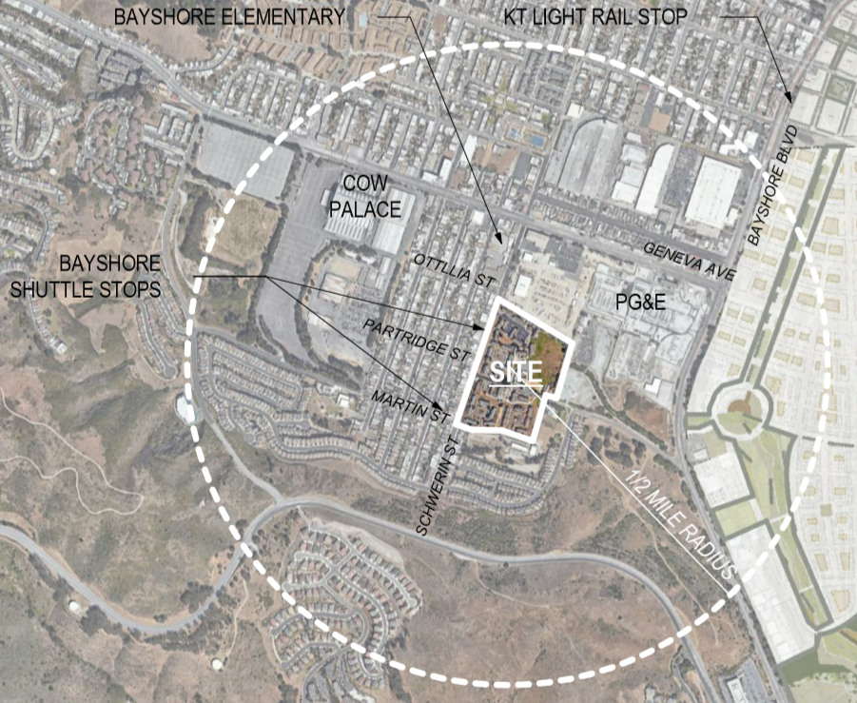

City of Daly City
Notice of Intent (NOI) to Adopt
Sustainable Communities Environmental Assessment (SCEA)
for
Midway Village Redevelopment
45 Midway Drive, Daly City
(APNs 005-330-020, 005-330-030, 005-330-040, 005-330-050, 005-330-060, 005-330-070, 005-330-080, 005-330-090, 005-330-100, 005-330-110, 005-330-120, 005-330-130,005-330-140, 005-330-150, 005-330-160, 005-330-170, 005-330-180, 005-330-190, 005-330-200, 005-330-210, 005-330-220, 005-330-230, 005-330-240, 005-330-250, 005-330-260, 005-330-270, 005-330-280, 005-330-290, 005-330-300, 005-330-310, 005-330-320, 005-330-330, 005-330-340, 005-330-350, 005-330-360, 005-330-370, 005-330-380, 005-330-390, and 005-330-400)
General Plan Amendment GPA-05-19-14054
Major Subdivision SUB-05-19-14055
Design Review DR-05-19-14056

Notice is hereby given that the City of Daly City will consider adoption of a Sustainable Communities Environmental Assessment (SCEA) for the above project that was reviewed pursuant to Section 21155.2 of the Public Resources Code (PRC) and a SCEA as specified under the California Environmental Quality Act (CEQA) streamlining provisions offered under SB375 for Transit Priority Projects.

The applicant, Mid-Pen Housing Corporation, is requesting approval to redevelop the Midway Village Housing Complex and the Bayshore Park to include mixed-use development consisting of 555 residential units, 746 parking spaces, a child-care facility, a community center, office space for property management and other ancillary services, a revised street system, and recreation facilities. The existing Bayshore Park would be relocated to a different location within the proposed project site and would be rough-graded before it is returned to the City and developed with various park amenities (development of the new park amenities is not part of the proposed project). The existing zoning for the site is R-3 Multiple Family Residential District and does not require amendment to allow the proposed number of units. The existing General Plan designation for the site is Residential High Density, allowing up to 50 units per acre. Although this designation allows the proposed number of units, a General Plan amendment is required to adjust the proposed location of Bayshore Park within the project site.

The public review period for the Draft SCEA begins on Monday, April 6, 2020, and ends on Tuesday, May 5, 2020. Persons interested in reviewing the Draft SCEA may review the document online at www.dalycity.org/45midwayscea or by contacting the Planning Division offices at (650) 991-8158, where an appointment can be made for review of the document.

Written Comments related to SCEA must be received no later than 5:00 p.m. on Tuesday, May 5, and shall be provided to:

Michael Van Lonkhuysen, Planning Manager
City of Daly City – Planning Division
333 90th Street, Second Floor
Daly City, CA 94015

The Planning Commission and City Council are tentatively scheduled to consider this project on May 5, 2020, and June 8, 2020, respectively. The Planning Commission meeting will be held in a virtual meeting format, unless otherwise announced, and can be attended by copying the following URL into your web browser: https://bit.ly/dalycitymay5. The City will provide the meeting location of the City Council through separate public notice.

Questions concerning the SCEA or project in general may be directed to Michael Van Lonkhuysen at (650) 991-8158.
Tatum Mothershead
Director of Economic & Community Development

Posted: Monday, April 6, 2020

